Portugal & Spain – 2026 Solar Eclipse Journey
A 18-day cultural, culinary, and scenic journey through Portugal and Northern Spain, designed around the Total Solar Eclipse on August 12, 2026.

Lisbon

Historic trams, Alfama alleys, vibrant viewpoint terraces, and UNESCO treasures of Belém.

Porto
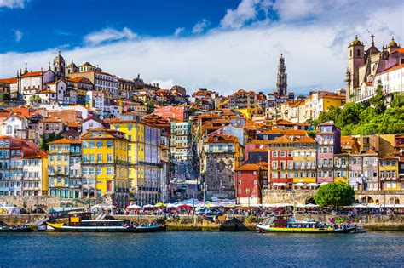
Port wine cellars, Douro River scenery, tiled churches, and atmospheric riverside dining.

Bilbao
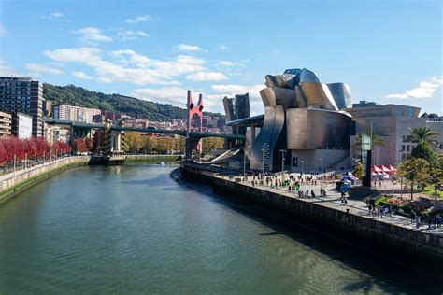
Guggenheim Museum, Basque cuisine, sleek riverside paths, and culture-forward neighborhoods.

Burgos
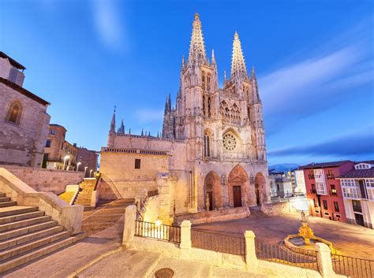
Gothic architecture, ancient Camino heritage, and the perfect eclipse-viewing location.

Madrid
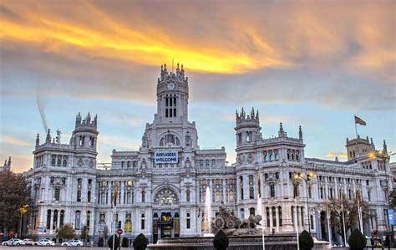
World-class art museums, royal palaces, lively plazas, and culinary experiences.

Detailed Day-by-Day Itinerary
Jul 30 — Flight into Lisbon
Jul 31 — Lisbon: Arrive; explore Alfama & Baixa.
Aug 1 — Lisbon: Belém: Jerónimos Monastery, Belém Tower, riverfront.
Aug 2 — Lisbon: Day trip to Sintra (Pena Palace & Quinta da Regaleira).
Aug 3 — Lisbon: Explore Chiado; optional Fado night.
Aug 4 — Porto: Train Lisbon → Porto; Ribeira & port lodges.
Aug 5 — Porto: Full-day Douro Valley wine experience.
Aug 6 — Porto: Serralves Museum, markets, leisure time.
Aug 7— Porto: Coastal visit to Foz do Douro (tram ride + lighthouse views)
Aug 8 — Bilbao: Fly Porto → Bilbao; pintxos crawl.
Aug 9 — Bilbao: Guggenheim Museum; riverside walk.
Aug 10 — Burgos: Travel to Burgos; visit Cathedral.
Aug 11 — Burgos: Museum of Human Evolution; old town.
Aug 12 — Burgos: Total Solar Eclipse Day — Viewing event.
Aug 13 — Madrid: Train Burgos → Madrid; tapas evening.
Aug 14 — Madrid: Prado, Retiro, Gran Vía.
Aug 15 — Madrid: Day trip: Toledo or Segovia.
Aug 16 — Return: Fly Madrid → LAX.

Estimated Trip Cost (Per Person)
• Hotels (17 nights): €1650 $1920
• Flights (LAX ↔ Europe + Porto → Bilbao): €1,200 $1400
• Trains & Buses: €200 $233
• Meals (~€60/day): €1,000 $1164
• Tours & Admissions: €450 $524
• Optional Winery Car Rental: €60 $70
Estimated Total: €4,200–€4,550 per person (approx. $4,900–$5,300 USD)

