Flights for the Eclipse Trip
I spent several hours yesterday (12/5/25) researching our flights and found that flights leaving on July 31st were significantly more expensive than those that depart on July 30th. So I moved the departure date to July 30 and added a day to the Porto agenda. That was an easy tradeoff; same price and an extra day in a fascinating city. I’ll be updating the itinerary online as the trip takes shape; this trip is a work in process and getting there and back is where we need to start. I did notice that many of the flights around the eclipse date and near the eclipse site are beginning to fill up especially our return flight out of Madrid. I’ll start nailing down the hotels next, but Car rentals are just starting to show availability issues in the eclipse region so I’ll be working on that along with the train transportation. Driving in Portugal and Spain is easy since they drive on the right side of the street just like the US, the highways are well marked, and google maps works well if you have a data plan for your phone. For most of the trip there is adequate public transportation and a car will not be necessary; the towns are small walkable.

Your To Do
Starting with https://www.google.com/travel/flights/ which sent me to Priceline for the best deals. Go to https://www.priceline.com/flights, and enter the information for your flights. Here is what I entered for Karen and me.

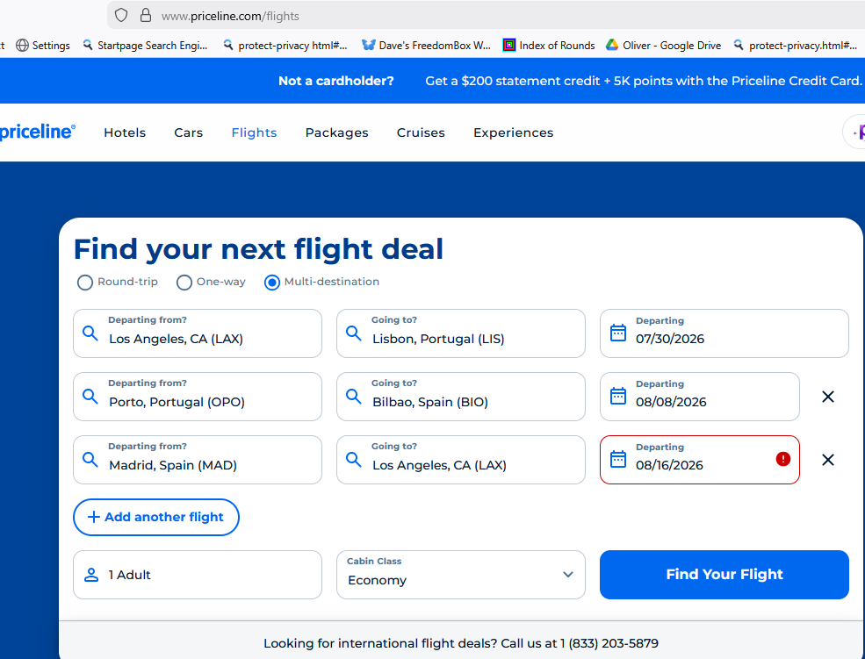
Your return airport
Your departure airport

Priceline.com gave several flight options and I selected the following information for our flights:

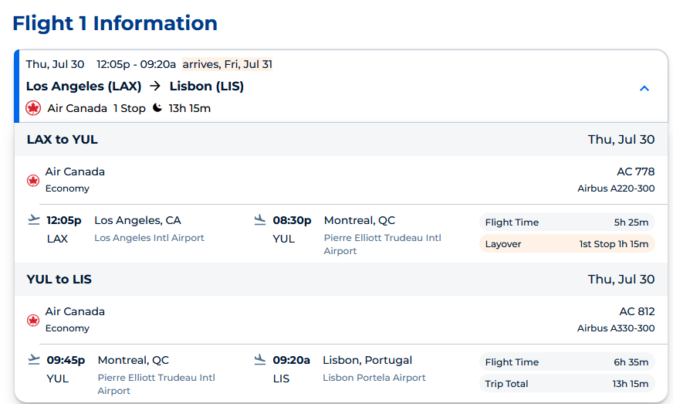
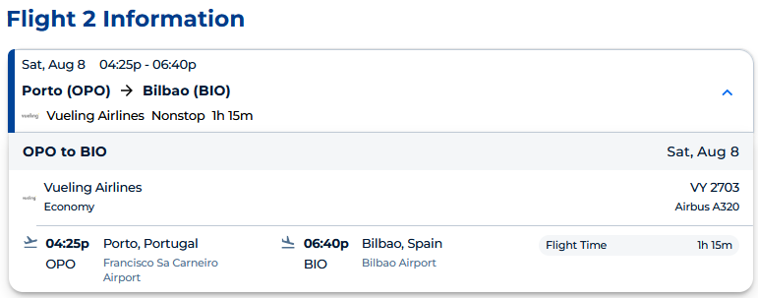
This was the only direct flight and it is later in the day, so more time in Porto and less time in Bilbao is the tradeoff.
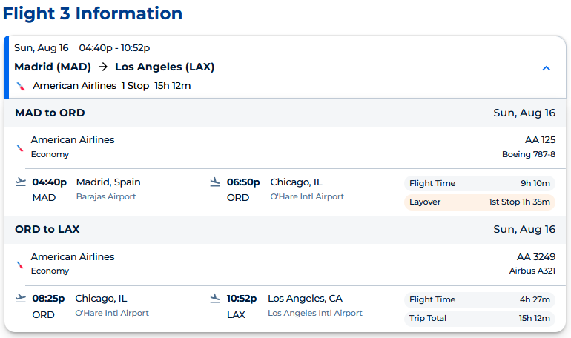
Note the times you have to cancel your flights if you change your mind. 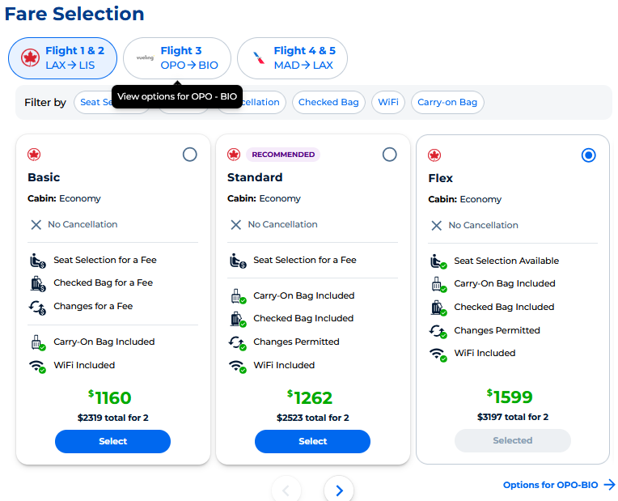
We chose the most forgiving and flexible option for our flights and needs; $1599 total, but on second thought using the $1262 option saves $367 but you pay about $250 for the seats you want and if you don’t care where you sit, this might be for you. There are more opulent options by clicking >. We also added “trip protection” insurance.

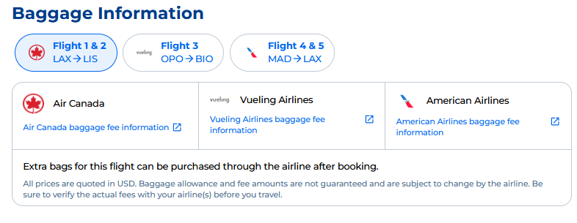
The next part is to check out and enter your personal information; name, KTN (known traveler number) if you have one, address, and credit card information. The KTN gives you PreCheck status avoiding the most uncomfortable parts of security and the line. We also have Clear, which uses biometrics to identify a traveler. With Clear and PreCheck one avoid lines and security hassles at U.S. International airports. Neither is necessary, but I failed line in 1st grade.

Since this is an international flight you WILL need a Passport that will not expire for at least 6 months after your date of entry into each country. Ours are good till 2029.

The flight from Porto to Bilbao has luggage restrictions that you should be aware of and conform to for the whole trip. Since this leg of the trip is the most restrictive, it influences all of the travel in Portugal and Spain. https://www.vueling.com/en/vueling-services/prepare-your-trip/luggage

We are taking one carry-on item and one small backpack that fits under the seat. Our selection of clothing reflects the summer season with the notion of layering if it gets cool. We prefer fast drying clothing that can be washed in a sink and hung in our room if need be. In South America we found that there are no laundromats and the people who wash your clothes for you don’t do so at your convenience. According to google Laundromats (Lavanderia) are readily available and of good quality.

I hope you found this useful.

