Portugal & Spain — 18-Day Solar Eclipse Trip
July 30 Departure Arrive July 31– August 16th 2026: Lisbon • Porto • Bilbao • Burgos (Eclipse) • Madrid

Trip Overview
A relaxed, cultural journey through Portugal and northern Spain, featuring the Total Solar Eclipse on August 12th, 2026 in Burgos. Designed for comfortable travel, boutique hotels, great food and wine, and minimal transit time. The Northern and coastal regions are the most comfortable in the summer while the middle of Spain is hot, but that’s where the eclipse is.

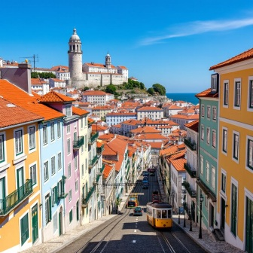
Itinerary at a Glance Note: Overnight Flight is not shown on this itinerary.

Days 1–4 – Lisbon (4 nights)
- Explore Alfama, Baixa, Belém & Chiado
- Fado music, riverfront walks
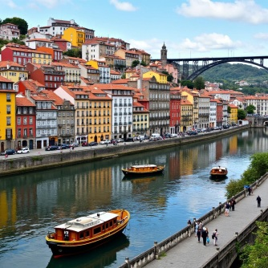
- Sintra day trip (Pena Palace & Regaleira)
Transport: Taxi/Uber + local trams/metro
Hotel: Memmo Alfama or Solar do Castelo

Days 5–8 – Porto (4 nights)
- Ribeira waterfront, Dom Luís Bridge
- Douro Valley winery day trip
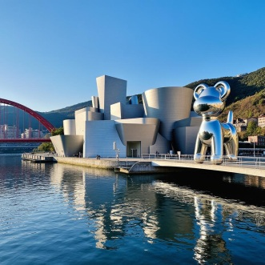
- Port wine lodges in Gaia
- Coastal visit to Foz do Douro (tram ride + lighthouse views)
Transport: Train Lisbon→Porto (~2h45)
Hotel: Torel Avantgarde or Infante Sagres

Days 9-10 – Bilbao (2 nights)
- Guggenheim Museum
- Pintxos in Casco Viejo

- Optional coastal visit (Getxo / Gaztelugatxe)
Transport: Flight Porto→Bilbao (~1h15)
Hotel: Tayko Bilbao or NYX Bilbao

Days 11–13 – Burgos (3 nights – Eclipse Base)
- Burgos Cathedral, Human Evolution Museum
- Ribera del Duero wine options
- SOLAR ECLIPSE — 12 August 2026
Transport: Train/bus Bilbao→Burgos (~1h40)
Hotel: Already reserved


Days 14–16 – Madrid (3 nights)
- Prado Museum, Retiro Park, Royal Palace
- Tapas in La Latina & San Miguel Market
- Day trip: Toledo or Segovia
Transport: Train Burgos→Madrid (~1h33)
Hotel: Only YOU Boutique or Catalonia Las Cortes

Day 17 – Departure
Madrid → LAX

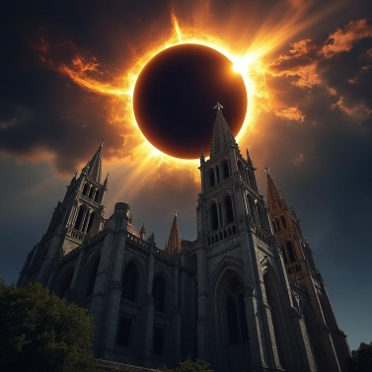
Estimated Per-Person Cost (4 travelers)
- Hotels (17 nights): €1,350 $1571
- Flights (LAX–Europe + Porto→Bilbao): €1,170
- Trains & buses: €160
- Meals & daily spending: €1,080
- Tours & entrance fees: €450
- Winery/rental car day: €60
→ Total Estimate: ~€4,270 (~$4,900–$5,000)

Trip Themes
History • Architecture • Food & Wine • Coastal Landscapes • Art & Culture • Local Small Towns • Eclipse Travel

Key Travel Advantages
- Minimal long-distance rail segments
- Efficient flight into Bilbao for Spain portion
- Eclipse-based lodging already secured
- Excellent August weather in northern Spain
- Balanced pace with free days for flexibility

